***Assignment –1***

**Creating sample tables and inserting values.**

Create the following tables with the given structures and insert sample data as specified: -

1. A) *SALESPEOPLE*

Snum int(4)

Sname varchar(10)

City varchar(10)

Comm float(3,2)

1. B) *CUSTOMERS*

Cnum int(4)

Cname varchar(10)

City varchar(10)

Rating int(4)

Snum int(4)

1. C) *ORDERS*

Onum int(4)

Amt float(7,2)

Odate date

Cnum int(4)

Snum int(4)

**SALESPEOPLE**

**CREATED NEW DATABASE NAMED ‘salesdata’**

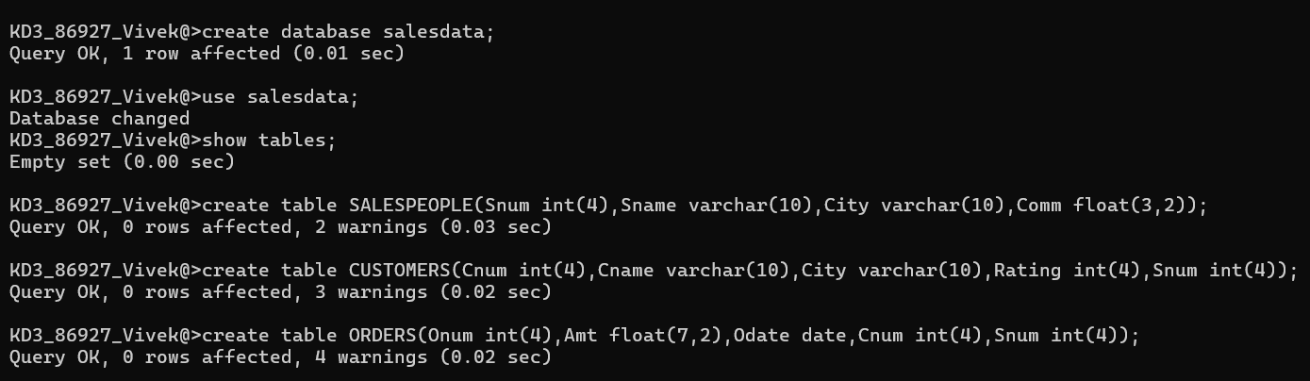

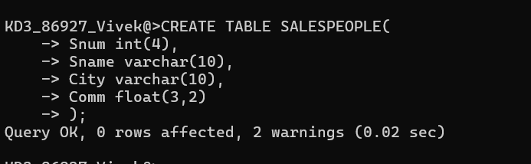

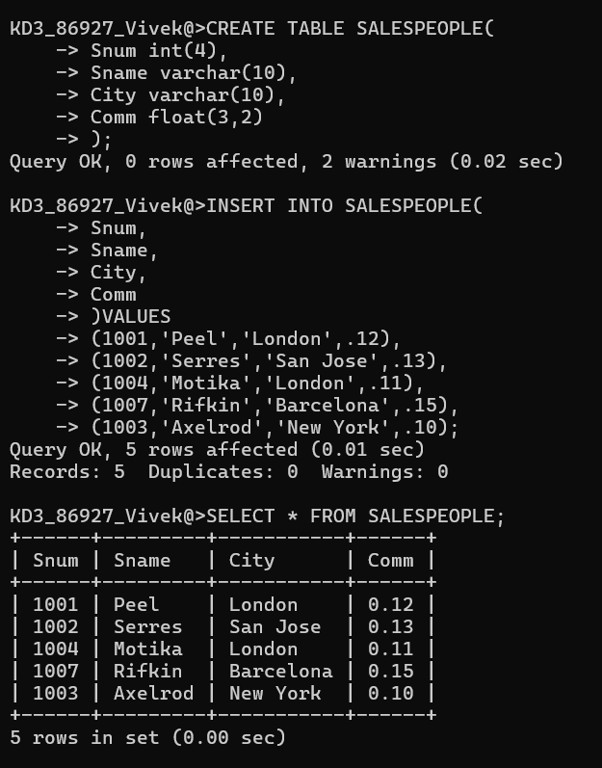

**CUSTOMERS**

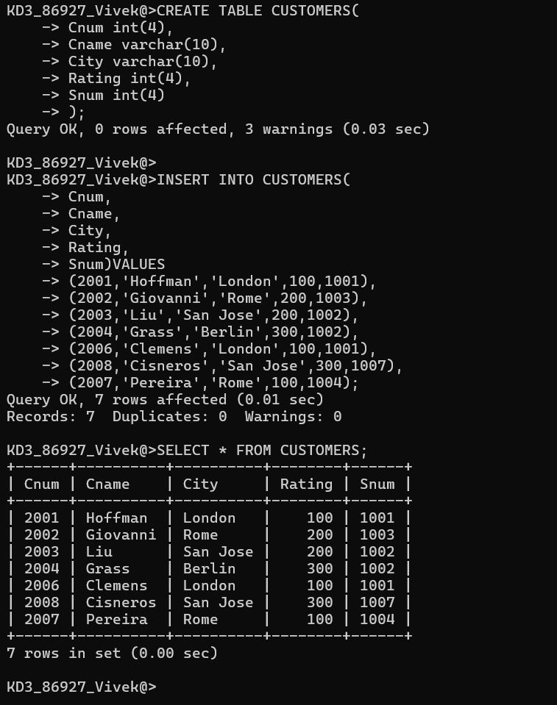

**ORDERS**

